

Web Design and Client Side Scripting  
Project Report

hdcyb_SEPOL  
Higher diploma in computing  
semester 1 2021

Walllaby Books  
[https://ncirlwebdesignproject.github.io](https://ncirlwebdesignproject.github.io/)

Svetlanna Avdeeva– x21138648

richard duffy – x20195966

Dragan Maracic – x21127794

due date – 07/12/2021

`

Contents

Executive Summary 2

Website Design and How We Split the Project Work 2

Wireframes 2

Project Timeline and Deliverables 4

Website Responsiveness 4

Frameworks 4

Website Deployment 5

Website Testing 5

HTML & CSS Validation: 5

Website speed test: 5

Website Optimisation 5

# Executive Summary

We decided to create a website for a fictional book publisher, Wallaby Books.

Dragan had an idea of a bookstore, but Richard advised that we should avoid getting into creating any kind of online sales system as that would involve a lot of server side development to adequately implement, so we decided to do a website for a fictional publisher company. Svetlana joined the team week after, and she was happy to move forward with the publisher idea.

The website is designed to be accessible to avid readers who may be interested in the publisher’s books. It presents information on the books and links out to where readers can buy the books.

Svetlana suggested the website also contain a blog that can provide content on what the publisher is up to, news on upcoming releases, and additional content to appeal to potential readers.

Richard suggested the site contain a storybook for younger children. This is designed to engage young readers through playful interaction, hopefully helping to instil an interest in books and reading at a young age so that these young readers may grow up to be consumers of the publisher’s books.

Lastly, we included a Contact page so that interested parties may reach out to the publisher with any questions or comments.

# Website Design and How We Split the Project Work

We decided to develop a page each for the site, with Richard also tackling the Contact page. Dragan would create wireframes for all pages using Figma, web-based graphics editing and a UI design app. Richard set up and managed the GitHub repo.

Dragan tackled the site Homepage where visitors could discover information on many books, with links out to where readers can buy those books. Dragan also built the footer for the website and developed the project report first draft.

Richard tackled the Storybook page and Contact page with form validation to capture details from users including a correctly formatted email address. The page was designed to format and send the data to a webhook that would be accepted by Slack, and some of this code is demonstrated. However, due to CORS protections, the data will not actually send as the XMLHttpRequest would have to be done in Server Side Code, which is outside the scope of the project. Richard also developed the Site Header Navigation with consistent CSS across all pages to help maintain consistency across the site.

Svetlana built the Blog page that would include news on upcoming releases, stories, and additional content for potential readers.

As soon as initial versions were assigned and finally completed, the project process became a lot more collaborative, and each member of the team helped each other where needed. This was accomplished using Microsoft Teams.

# Wireframes

The four screenshots below show the Wireframe design for our Homepage, Blog, Book and Contact page. This was done using the UI design tool Figma. (<https://www.figma.com/>)

Homepage Wireframe Blog Wireframe

Book Wireframe Contact Wireframe

# Project Timeline and Deliverables

Week 1: Website wireframe design and GitHub repo creation

Week 2: Creation of Homepage, Blog, Book, and Contact page

Week 3: Added swiper on the Homepage, added a new story on Book page, final tweaks (JS, HTML, CSS) on all pages

Week 4**:** Form validation, deployment, testing, optimization, report, and PowerPoint presentation writing.

# Website Responsiveness

Using Bootstrap (CSS & JS) and media queries (CSS) allowed us to create different layouts depending on the size of the viewport. Inspect element tool, a built-in feature in every browser, helped us in this process. For example, on smaller devices such as smartphones, the navigation bar and logo transform to a central position on the screen.

# Frameworks

As mentioned above, we used Bootstrap and jQuery as frameworks to build our website. A jQuery plugin SwiperJS was used to create more dynamic visuals on the homepage.​

TurnJs was used for the Book page to give the page-turning affect. A suitable template was used and then additional HTML was used within the pages which was DOM manipulated using further, custom JavaScript. The TurnJS elements were also modified in style.css to sit within the site design and layout.​

# Website Deployment

The project was managed through GitHub. A standalone profile was created so that the site could be deployed from that profile’s GitHub pages homepage, and then each group member was added as a collaborator from their own GitHub profile.​

Group members worked in separate branches so that any conflicts in work could be spotted and flagged before merging a Pull Request.​ The URL for our website is: [https://ncirlwebdesignproject.github.io/](https://ncirlwebdesignproject.github.io/index.html)

# Website Testing

## HTML & CSS Validation:

We used the HTML (<https://validator.w3.org/>) and CSS validators (<https://jigsaw.w3.org/css-validator/>). Each team member validated their pages and if any errors were shown by the validator, they were corrected afterwards.

### Homepage index.html validation

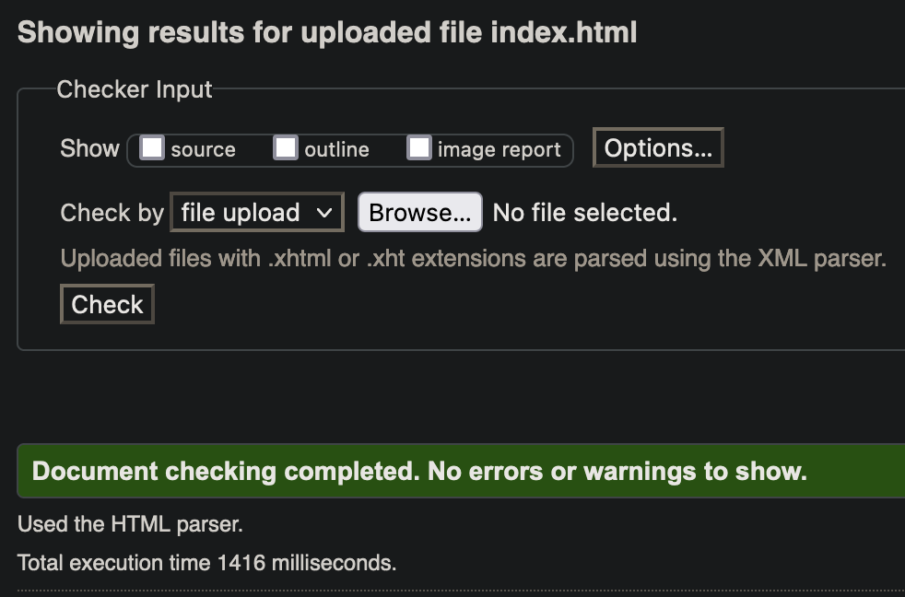

### Blog index.html validation

### Book index.html validation

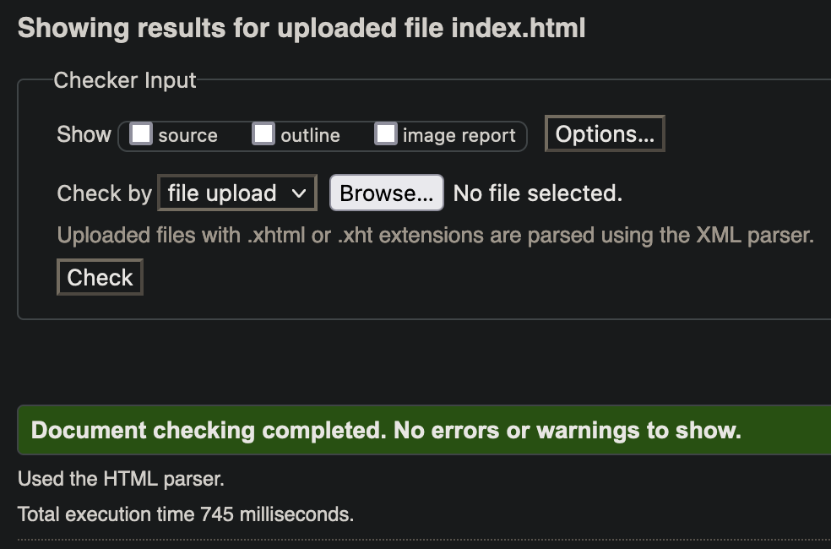

### Contact index.html validation

### book.css validation

### book.min.css validation

### ourbooks.css validation

### style.css validation

### style.min.css validation

### styles.css validation

## Website speed test:

We used Google PageSpeed (<https://pagespeed.web.dev/>) to analyze and optimize our website.

### Homepage pagespeed analysis

Mobile Desktop

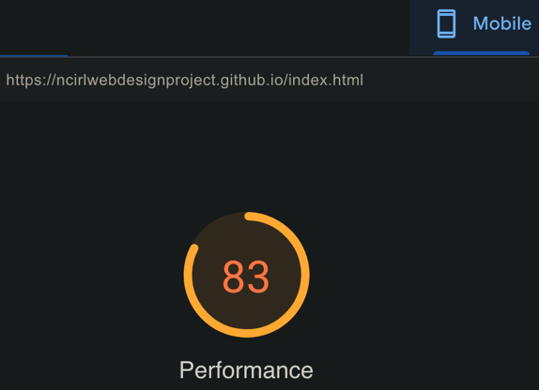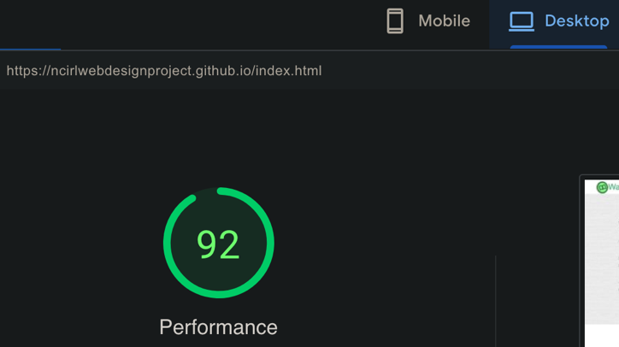

### Blog page pagespeed analysis

### Book page pagespeed analysis

Mobile Desktop

### Contact page pagespeed analysis

Mobile Desktop

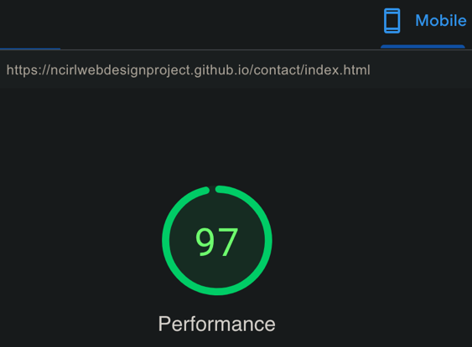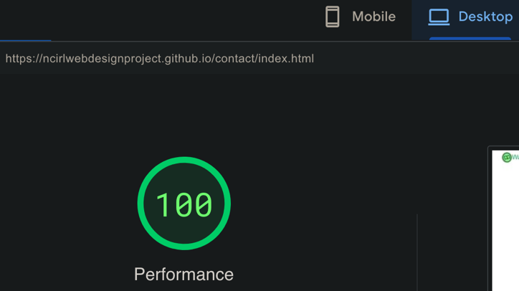

# Website Optimisation

To optimise the speed of our website included, the following actions were taken:

CSS and JS files were minified (and merged where possible). Images were created at the desired display sizes so that the browser would not need to do any resizing.​

Google PageSpeed analysis identified that the older .jpeg and .png image formats were significantly contributing to the page load speed on the Book page. Also, it identified some superfluous JavaScript and CSS files being loaded which were not being used by the page. These links were removed, and the image files were converted to WebP, an image format which provides more efficient data compression. This led to significant improvements. In particular, the Book page was raised from a Google PageSpeed score of 62 on mobile to a score of 85.​

To increase the SEO (Search Engine Optimisation) of our website, the meta tags for each page were edited. Each page was given a distinct title. Full Descriptions were written for the pages, and appropriate Keyword tags added. The meta tags also explicitly flagged the pages for indexing, rather than just relying on this behaviour being the default.